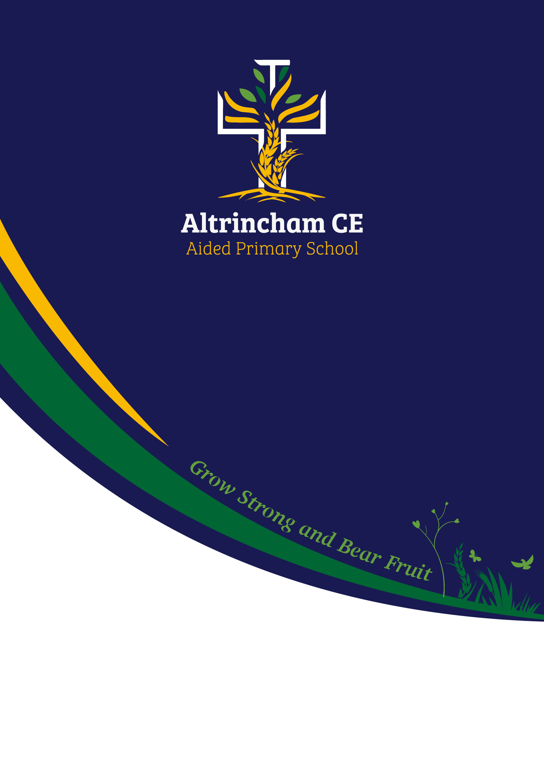

**Collective Worship Policy**

**October 2024**

Relationships

Policy

October 2024

**Altrincham CE Primary School Vision**

**Altrincham CE Primary School Mission**

Our mission, as a primary school with a strong Christian foundation is to provide an education which is deeply rooted within love, friendliness and a strong tradition of the Christian faith which ensures the children and adults have a nurturing and aspirational environment to reach their full potential, living life in all its fullness. Loving God and each other is lived out in the everyday life of school.

**Altrincham CE Primary School Vision**

******At Altrincham CE Primary, we are rooted in the love of Christ, nurturing each pupil’s unique gifts and potential. Together, we grow strong in faith and character, bearing fruit in our community as we learn, support one another, and blossom into the best version of ourselves.

***Grow Strong and Bear Fruit***

**Our vision is rooted in the Parable of the Sower:**

***Matthew 13:8 The Message***

“What do you make of this? A farmer planted seed. As he scattered the seed, some of it fell on the road, and birds ate it. Some fell in the gravel; it sprouted quickly but didn’t put down roots, so when the sun came up it withered just as quickly. Some fell in the weeds; as it came up, it was strangled by the weeds. Some fell on good earth, and produced a harvest beyond his wildest dreams.”

This policy will be reviewed every two years or sooner in light of any advice from Chester Diocese Board of Education.

**Collective Worship Policy**

**What is Worship?**

Worship is a fundamental aspect of the spiritual life within our school, encompassing a range of practises that express reverence, adoration, and devotion to God:

* **Spiritual Connection**: Worship is the act of engaging with God, recognising His presence, and responding to His love and grace. It serves as a means for pupils and staff to deepen their relationship with God and to seek His guidance in their lives.
* **Community Gathering:** Worship is a communal activity that brings together pupils, staff, and the wider school community. It fosters a sense of belonging and unity, allowing individuals to share in the experience of faith and spirituality.
* **Expression of Faith:** Worship encompasses various forms of expression, including prayer, singing, reading of Scripture, and reflection. These elements help to articulate the beliefs and values of the Christian tradition, encouraging participants to engage with their faith actively.
* **Educational Component:** Worship is not only about spiritual practice but also about education. It provides opportunities for pupils to learn about the Christian faith, the teachings of Jesus, and the significance of the Church’s liturgical calendar.
* **Moral and Ethical Development:** Through worship, pupils are encouraged to reflect on their actions and values, fostering a sense of moral responsibility and ethical living in accordance with Christian principles.
* **Celebration of Life's Moments:** Worship acknowledges and celebrates significant moments in the school year, such as festivals, achievements, and challenges, integrating these experiences into the spiritual life of the school.
* **Inclusivity:** While rooted in the Christian tradition, worship should be inclusive, welcoming all pupils regardless of their background, and fostering an environment of respect and understanding for diverse beliefs.

In summary, worship is a holistic practice that nurtures spiritual growth, community, and moral development, rooted in the teachings of the Christian faith. It is an essential part of our school’s ethos, aiming to cultivate a vibrant and supportive environment where pupils can flourish both academically and spiritually.

We believe, therefore that worship is:

***“An expression of a relationship with God and a desire to serve and love God, and others.”***

Our daily act of worship underpins our vision and we consider Collective Worship to be at the heart of our school; an important and special time within our school day together. As a school, we also recognise that worship should be inclusive, invitational and inspiring opportunities for reflection.

Collective Worship strengthens and supports the Christian Distinctiveness of our school, develops our Christian vision, reaffirms our values and celebrates the contributions of every child and adult within school.

We have a strong partnership with the churches of St George’s and St Margaret’s and aim to conduct worship both in school and at church.

**Aims for Collective Worship in our school**

* **To provide opportunities for our pupils to:**
* Understand what worship is and what people do when they when they worship
* Worship God in their own way, developing their own spirituality and relationship with God
* Consider and reflect upon social and moral issues
* Look out to the wider world and take note of events through appropriate expression of joy or sorrow
* Celebrate and give thanks for God’s world
* Explore their own commitments, beliefs and values
* Develop behaviour based on Christian values
* Deepen their awareness of the needs of others
* Gain knowledge, understanding and respect for other World Faiths and their traditions
* **To develop knowledge and understanding of the Christian Faith by:**
* Learning about the use and significance of The Bible
* Understanding the significance of Jesus
* Celebrating the festivals and Saints days of the Church year
* Showing that God is concerned with all areas of life
* Develop an understanding of the Trinitarian nature of God
* Explore Global Christianity and similarities and differences around the world
* **To contribute to pupils’ spiritual development by:**
* Developing the ability to reflect, to be still and to use silence creatively
* Learning to pray in a variety of ways
* Foster a sense of awe and wonder at creation and in nature
* Exploring the important questions about life and creation including the difficult side of life e.g. suffering, loss and death
* Exploring all that is of value in life – truth, love, goodness and beauty.
* Reflecting on and expressing their hopes, concerns, joys and sorrows.
* **To encourage pupils to respond and participate with enjoyment through**:
* Active involvement in Collective Worship through a range of creative opportunities e.g. music, silence, symbolism, story and drama.
* Reflecting on the impact of important issues on their own lives
* **To celebrate life in school in the presence of God by:**
* Building a sense of community (koinonia) in school
* Developing and reflecting on the school’s Christian values
* Celebrating pupils’ learning and personal development in all areas of the curriculum where they have had an opportunity to ‘Grow Strong and Bear Fruit’.

“Some fell on good earth, and produced a harvest beyond his wildest dreams.”

* **To promote a common ethos and shared values reflecting the Christian tradition, yet with regard and respect for the various faith communities represented within the school.**
* **To reinforce positive attitudes through deep exploration of our core Christian Values and their impact on everyday life.**

**The Principles of Collective Worship**

* **Respect for all members of the school community**
* **Sensitivity to the ideas explored and beliefs shared i.e.**
* Recognition as a special time within the school day
* Opportunity to share values and experiences
* Informing pupils about the Christian Faith and to sensitively draw out any similarities and comparisons with other major World Faiths represented by the pupils attending school
* Celebrating the work and word of God and the life and teachings of Jesus+ v

**The Organisation of Collective Worship:**

There are worship opportunities shared with our pupils every day.

|  |  |  |  |
| --- | --- | --- | --- |
| **Day** | **Year Groups and Who** | **Content** | **Throughout the week:** |
| Monday | Whole School. Church Team | **Introduction:**  Call to Worship for the week  New Song for the week  Memory Verse for the half term  Pray | Reflective response area  Worship Books |
| Tuesday | KS1 – VW  KS2 – SW | **Outline:**  Call to Worship, Song, Memory Verse  Story/Bible Passage  Reflective Questions |
| Wednesday | KS2 – KC  KS1 – Class | KC:  **Grounding in lived experiences:**  Call to Worship, Song, Memory Verse  Application to lived life experiences  Class:  **Discussion of reflective questions:**  Call to Worship, Song, Memory Verse  Opportunity to discuss the questions & opportunity to respond  Challenges that might arise |
| Thursday | KS2 – Class  KS1 – KC | KC:  **Grounding in lived experiences:**  Call to Worship, Song, Memory Verse  Application to lived life experiences  Class:  **Discussion of reflective questions:**  Call to Worship, Song, Memory Verse  Opportunity to discuss the questions & opportunity to respond  Challenges that might arise |
| Friday | KS1 – VW  KS2 - SW | **Celebration:**  Call to Worship, Song, Memory Verse  Call to Worship, Song, Verse  **Celebrate!**  Kit Bag – what needs to be added into it this week? |

Children are also given the opportunity to worship in a variety of settings at significant points of the year e.g. St George’s Church Altrincham. St Margaret’s Church Altrincham and worship will be help outside in the open air when possible.

Worship is inclusive and open to all members of the school community regardless of ability, background, age or lifestance.

There will only be exception for pupils whose parents have requested in writing, the right to withdraw their children due to faith commitments. In these cases, alternative arrangements will be made through the Head Teacher.

Though worship is not designated as curriculum time under current regulations, it is a major aspect of the whole curriculum provided by the school. Worship is a vehicle for exploring aspects of the National Curriculum and Religious Education and frequently involves teaching and learning activities such as discussion and question and answer. Pupils may be read to or instructed, or they may be asked to listen to readings or think about and respond to a stimulus such as a work of art.

Worship is also concerned with the celebration of the curriculum, with pupils displaying or recounting details of what they have learnt. Pupils are involved in leading worship or performing through dance, drama or music.

When any such activities occur, they may be counted as teaching time even though they take part in worship. It is appropriate that in a Church School worship and learning is seen as a seamless whole even though, for the purposes of recording teaching time, we distinguish between the two.

We believe that it is important to develop a real sense of what it is to worship amongst our children. With this in mind, the following elements will characterise our worship together:

* That children and staff enter and leave the place of worship in a quiet and peaceful manner
* That an appropriate medium will be used to set the tone for worship, e.g. music may be played or silence required.
* That there will be a visible focus for worship in the form of a Christian symbol together with other items of display e.g. artefacts, our school vision and values tree

The main element of each assembly will be the fact of worship, but assemblies will also be used as an opportunity to give out awards, notices and certificates.

**The Content of our Collective Worship**

**General Content**

In the course of a school year, worship will be planned around our school vision and values, but worship will aim to l provide opportunities to incorporate many of the following:

* Sharing and taking note of common experiences – loss, death, birthdays, anger, thankfulness, sorrow, joy, fear, jealousy, beauty, endings, good-byes, new siblings, illness and recovery.
* Expressing concern for others, both in stories and from school and in the news.
* Looking at the world, developing awe and wonder, exploring mystery, pattern, order, change, renewal and thanksgiving.
* Exploring common values, standards and rules – how to treat others, self-discipline, forces for good and bad.
* Topical events: continuing issues such as starvation, peace and conflict.
* Celebrating the curriculum.
* Sharing and celebrating achievements in sports, hobbies, relationships and behaviour inside and outside of school.
* Stories which illustrate themes of faith, such as biographies or which explore metaphor.
* Information about faiths including key personalities and their stories.
* Music – from a variety of sources; recorded or performed by pupils and staff.

As we believe that our worship should recognise the distinct nature of our school, the inclusion of material listed above will always be delivered clearly and explicitly in a way which points to God.

In addition, there will be content which is specifically Christian drawn from the following:

**The Christian Faith and History**

* Understanding the nature of The Bible
* Old Testament Stories
* Stories about the teachings of Jesus
* Church seasons and festivals
* Church History
* Stories of saints and famous Christian people, who exemplify Christian virtues and values, chosen from the past and the present, and taken from a range of cultural backgrounds
* Christian beliefs
* Christian values e.g. forgiveness, reconciliation, mercy, self-sacrifice, compassion and love.

**Prayer and God**

* Exploring ideas about prayer as well as practising the habit of prayer to God.
* Using different forms of prayer to express acknowledgement of failings and wrong doings, confession, forgiveness and reconciliation as well as thanksgiving, praise and petition.

At Altrincham CE, we embed opportunities throughout the curriculum and Collective Worship for spiritual development incorporating a range of spiritual styles. In particular, we will be using the ‘windows, mirrors and doors’ analogy as the basis for our framework:

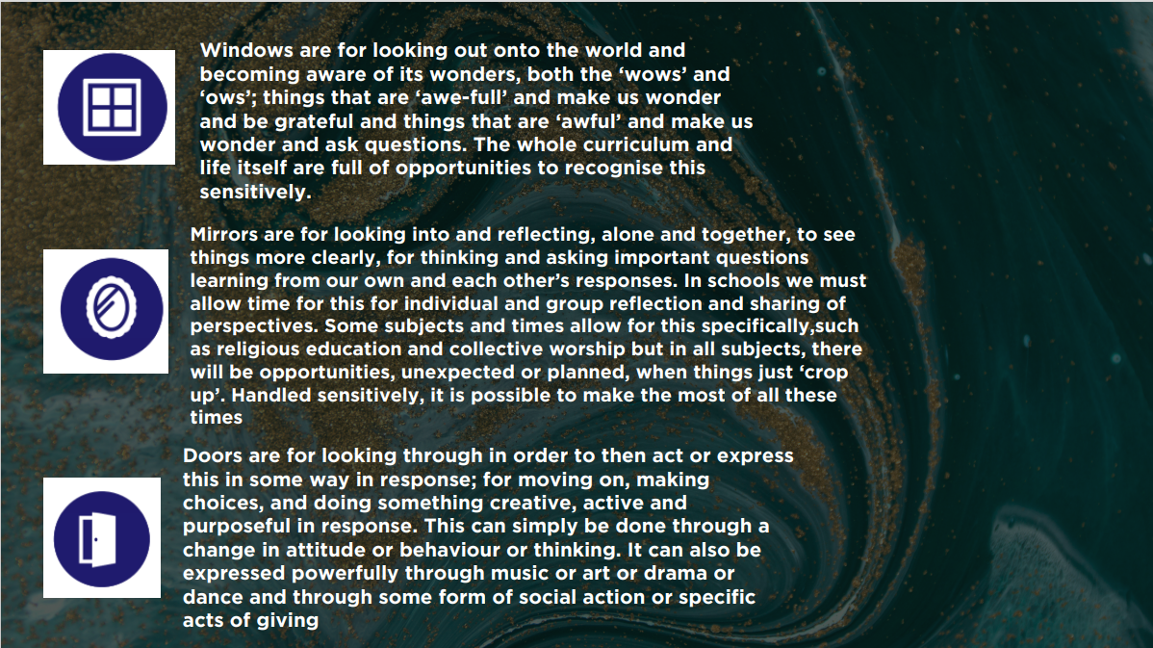

**The Legal Requirements for Collective worship in our School**

**Legal Basis**

Collective Worship in Church Schools is governed by both the 1944 and 1988 Education Acts (as consolidated in the 1996 Act) as well as the Trust Deed of the school. The Collective worship provided by the school must be in accordance with the Trust Deed.

**Daily Worship**

Daily Collective Worship has to be provided for every pupil. This worship may take place in various groupings such as whole school, separate Key Stage groups, year groups or in classes, but not faith groups. Worship may take place at any point in the school day.

**Parents Rights of Withdrawal**

Parents may withdraw their children from Collective worship and this provision. The Governors have agreed with the following form of words on this subject:

“The Worship and Religious Education provided by the school is in accordance with the Church of England Foundation. This Foundation is also reflected in the curriculum and the whole life of the school community. Since the conduct of the school as a whole reflects the Church of England ethos, removal of pupils from Worship and or Religious Education (as parents are legally entitled to do) cannot insulate pupils from the religious life of the school.”

**Complaints About the Provision of Collective Worship**

Any complaints about Collective Worship should be addressed to the Head Teacher who will attempt to resolve them informally, in consultation with the Governors, and possibly advice from the Diocese. However, if the complaint is not satisfactorily resolved, then formal procedures will be followed and the matter will be adjudicated by the Diocesan Board of Education acting on behalf of the Bishop of the Diocese.

**The Legal Requirements for Collective Worship in our School**

The aims for worship in our multi-faith Church school have been carefully considered in order to recognise that Christian Worship needs to be maintained but in a way that allows children from other faiths and no faith, to feel included and to take part.

The Christian framework for worship has been maintained, but without violating the integrity of pupils from other faiths. Material used in worship will regularly be drawn from Christian sources, inviting pupils to explore and respond to Christian stories and Christian values and to see what is important to Christians by thinking about prayers, beliefs and practices.

As important, however, is the witness to the Christian faith carried out through the life of the school, the way the adults and children relate to each other, the expectations of all members of the community and the life of service lived day by day.

Pupils will not be coerced into anything that would be against their faith or beliefs. For example, joining in with hymns, calls to worship and prayers is invitational. Whilst the whole act of worship will be clearly consistent with Christianity all attempts are made to ensure that it does not cause offence to our staff and pupils from other faiths or no faith.

**Responsibility for the Collective Worship and this Policy**

This policy was approved by the Governing on the date on the front of the document. The policy was produced by the Head Teacher who is the coordinator for Collective Worship, in conjunction with the clergy from St George’s Altrincham. It was discussed by the whole staff and by the Full Board of Governors.

It is the responsibility of the Governing Body, to ensure that Collective Worship takes place in school in accordance with the Trust Deed.

Class teachers are responsible for delivering their own Classroom Collective Worship, which follows our half termly core value.

**Review and Monitoring**

Our programme of worship is planned and reviewed by the Senior Leadership Team and the clergy of St George’s Church, Altrincham.

The quality, variety and impact of worship delivered is evaluated by all stakeholders: SLT, Governors, St George’s Altrincham, parents, Children’s Chaplains and pupils.